Artificial Intelligence with Python – LAB TASK 3

Kartik Srinivas 16BIS0085

Question:

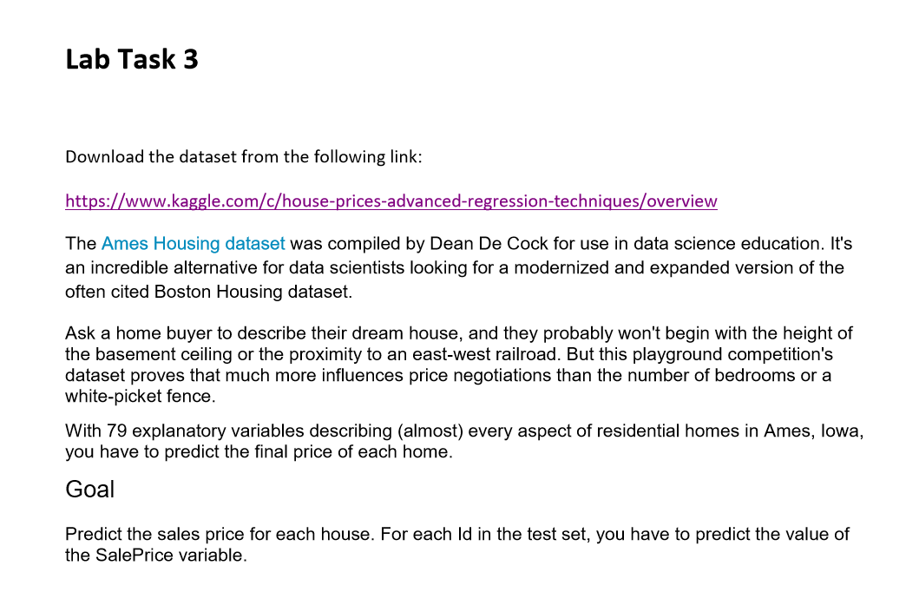

Answer:

**from** typing **import** List  
**import** numpy **as** np  
**import** pandas **as** pd  
**from** sklearn.tree **import** DecisionTreeRegressor  
**from** sklearn.metrics **import** mean_absolute_error  
**from** sklearn.metrics **import** mean_squared_log_error  
**import** matplotlib.pyplot **as** plt  
  
*#READ CSV FILE*train_file = **r'C:\Users\karti\Desktop\Fall Semester 2019-20\Artificial Intelligence with Python\Lab\task3\train.csv'**data = pd.read_csv(train_file)  
summary = data.describe()  
  
*#SELECT THE FEATURES, DEFINE MODEL*y = data.SalePrice  
data_features = [x **for** x **in** data.columns **if** str(data[x][0]).isdigit()][:-1]  
X = data[data_features]  
describe = X.describe()  
head = X.head()  
  
*#FIT MODEL*data_model = DecisionTreeRegressor(random_state=1)  
data_model.fit(X, y)  
X = np.array(X)  
  
*#PREDICTION*test_file = **r'C:\Users\karti\Desktop\Fall Semester 2019-20\Artificial Intelligence with Python\Lab\task3\test.csv'**test_data = pd.read_csv(test_file)  
X_test = test_data[data_features]  
X_test = pd.DataFrame(X_test).fillna(X_test.mean())  
print(X_test)  
result = data_model.predict(X_test)  
print(result)  
  
*# %%*submission_file = **r'C:\Users\karti\Desktop\Fall Semester 2019-20\Artificial Intelligence with Python\Lab\task3\submission.csv'**submission_data = pd.read_csv(submission_file)  
  
*# ROOT MEAN SQUARE ERROR & ROOT MEAN SQUARE LOG ERROR*print(**'RMSE is: '**, (mean_absolute_error(submission_data[**'SalePrice'**], result)) ** 0.5)  
print(**'RMSLE is: '**, (mean_squared_log_error(submission_data[**'SalePrice'**], result)) ** 0.5)

